**1.Design a command-line calculator that performs arithmetic operations (addition, subtraction, multiplication, division) on fuzzy numbers. Implement fuzzy arithmetic operations using appropriate fuzzy logic rules and membership functions. Test the calculator with different fuzzy numbers and evaluate the accuracy of the results.**

import numpy as np

class FuzzyNumber:

def __init__(self, value, membership_function):

self.value = value

self.membership_function = membership_function

def fuzzy_addition(a, b):

result_value = a.value + b.value

result_membership_function = np.minimum(a.membership_function, b.membership_function)

return FuzzyNumber(result_value, result_membership_function)

def fuzzy_subtraction(a, b):

result_value = a.value - b.value

result_membership_function = np.minimum(a.membership_function, 1 - b.membership_function)

return FuzzyNumber(result_value, result_membership_function)

def fuzzy_multiplication(a, b):

result_value = a.value * b.value

result_membership_function = np.minimum(np.maximum(a.membership_function, b.membership_function),

np.minimum(a.membership_function, b.membership_function))

return FuzzyNumber(result_value, result_membership_function)

def fuzzy_division(a, b):

if b.value == 0:

raise ValueError("Division by zero is undefined.")

result_value = a.value / b.value

result_membership_function = np.minimum(a.membership_function, 1 / b.membership_function)

return FuzzyNumber(result_value, result_membership_function)

**# Example usage**

a = FuzzyNumber(5, np.array([0, 0.4, 0.8, 1, 0.6, 0.2, 0]))

b = FuzzyNumber(3, np.array([0, 0.2, 0.6, 1, 0.4, 0, 0]))

result_addition = fuzzy_addition(a, b)

result_subtraction = fuzzy_subtraction(a, b)

result_multiplication = fuzzy_multiplication(a, b)

result_division = fuzzy_division(a, b)

print("Fuzzy Addition:", result_addition.value)

print("Fuzzy Subtraction:", result_subtraction.value)

print("Fuzzy Multiplication:", result_multiplication.value)

print("Fuzzy Division:", result_division.value)

**Output:-**

**Fuzzy Addition: 8**

**Fuzzy Subtraction: 2**

**Fuzzy Multiplication: 15**

**Fuzzy Division: 1.6666666666666667**

**4.Design and implement a single-layer perceptron from scratch using Python. Train the**

**perceptron on a binary classification problem**

import numpy as np

class SingleLayerPerceptron:

def __init__(self, input_size):

**# Initialize weights and bias**

self.weights = np.zeros(input_size)

self.bias = 0

def predict(self, inputs):

**# Calculate the weighted sum and apply step function**

linear_output = np.dot(inputs, self.weights) + self.bias

prediction = np.where(linear_output >= 0, 1, 0)

return prediction

def train(self, inputs, labels, learning_rate=0.1, epochs=100):

for epoch in range(epochs):

for input_data, label in zip(inputs, labels):

prediction = self.predict(input_data)

**# Update weights and bias based on prediction error**

update = learning_rate * (label - prediction)

self.weights += update * input_data

self.bias += update

**# Print accuracy for each epoch**

accuracy = self.evaluate(inputs, labels)

print(f"Epoch {epoch + 1}/{epochs}, Accuracy: {accuracy:.2%}")

def evaluate(self, inputs, labels):

predictions = np.array([self.predict(input_data) for input_data in inputs])

accuracy = np.mean(predictions == labels)

return accuracy

**# Example usage**

if __name__ == "__main__":

**# Generating some random data for binary classification**

np.random.seed(42)

input_size = 2

num_samples = 100

inputs = np.random.rand(num_samples, input_size)

labels = np.random.randint(2, size=num_samples)

**# Instantiate and train the perceptron**

perceptron = SingleLayerPerceptron(input_size)

perceptron.train(inputs, labels, learning_rate=0.1, epochs=100)

**# Evaluate accuracy on the training data**

accuracy = perceptron.evaluate(inputs, labels)

print(f"Final Accuracy: {accuracy:.2%}")

**Output:-**

Epoch 1/100, Accuracy: 51.00%

Epoch 2/100, Accuracy: 55.00%

Epoch 3/100, Accuracy: 55.00%

Epoch 4/100, Accuracy: 53.00%

……

……

……

……

……

Epoch 99/100, Accuracy: 53.00%

**Final Accuracy: 54.00%**

**5. Develop a Multi-Layer Perceptron (MLP) for any real world problem.**

import numpy as np

from sklearn.datasets import load_iris

from sklearn.model_selection import train_test_split

from sklearn.preprocessing import StandardScaler

from sklearn.neural_network import MLPClassifier

from sklearn.metrics import accuracy_score

**# Load Iris dataset**

iris = load_iris()

X = iris.data

y = iris.target

**# Split the dataset into training and testing sets**

X_train, X_test, y_train, y_test = train_test_split(X, y, test_size=0.2, random_state=42)

**# Standardize features**

scaler = StandardScaler()

X_train = scaler.fit_transform(X_train)

X_test = scaler.transform(X_test)

**# Create and train MLP model**

mlp = MLPClassifier(hidden_layer_sizes=(5, 1), max_iter=1000, random_state=42)

mlp.fit(X_train, y_train)

**# Make predictions on the test set**

y_pred = mlp.predict(X_test)

**# Evaluate accuracy**

accuracy = accuracy_score(y_test, y_pred)

print(f"Accuracy: {accuracy}")

**output:-Accuracy: 0.9333333333333333**

**3.Design a fuzzy logic controller for a washing machine that adjusts the wash cycle based on the level of dirtiness and fabric type. Define fuzzy sets and membership functions for dirtiness level (e.g. low, medium, high) and fabric type (e.g., delicate, cotton, heavy-duty). Create fuzzy rules to determine the wash cycle duration, water temperature, and detergent amount based on dirtiness level and fabric type. Implement the fuzzy logic controller and evaluate its effectiveness in achieving clean and undamaged clothes in python.**

import numpy as np

import skfuzzy as fuzz

from skfuzzy import control as ctrl

import matplotlib.pyplot as plt

# Define input variables

dirtiness_level = ctrl.Antecedent(np.arange(0, 11, 1), 'dirtiness_level')

fabric_type = ctrl.Antecedent(np.arange(0, 11, 1), 'fabric_type')

# Define output variables

wash_cycle_duration = ctrl.Consequent(np.arange(0, 61, 1), 'wash_cycle_duration')

water_temperature = ctrl.Consequent(np.arange(0, 101, 1), 'water_temperature')

detergent_amount = ctrl.Consequent(np.arange(0, 101, 1), 'detergent_amount')

# Define fuzzy sets and membership functions

dirtiness_level['low'] = fuzz.trimf(dirtiness_level.universe, [0, 0, 5])

dirtiness_level['medium'] = fuzz.trimf(dirtiness_level.universe, [0, 5, 10])

dirtiness_level['high'] = fuzz.trimf(dirtiness_level.universe, [5, 10, 10])

fabric_type['delicate'] = fuzz.trimf(fabric_type.universe, [0, 0, 5])

fabric_type['cotton'] = fuzz.trimf(fabric_type.universe, [0, 5, 10])

fabric_type['heavy_duty'] = fuzz.trimf(fabric_type.universe, [5, 10, 10])

# Define fuzzy sets and membership functions for outputs

wash_cycle_duration['short'] = fuzz.trimf(wash_cycle_duration.universe, [0, 0, 30])

wash_cycle_duration['medium'] = fuzz.trimf(wash_cycle_duration.universe, [0, 30, 60])

wash_cycle_duration['long'] = fuzz.trimf(wash_cycle_duration.universe, [30, 60, 60])

water_temperature['cold'] = fuzz.trimf(water_temperature.universe, [0, 0, 50])

water_temperature['warm'] = fuzz.trimf(water_temperature.universe, [0, 50, 100])

water_temperature['hot'] = fuzz.trimf(water_temperature.universe, [50, 100, 100])

detergent_amount['low'] = fuzz.trimf(detergent_amount.universe, [0, 0, 50])

detergent_amount['medium'] = fuzz.trimf(detergent_amount.universe, [0, 50, 100])

detergent_amount['high'] = fuzz.trimf(detergent_amount.universe, [50, 100, 100])

# Define fuzzy rules

rule1 = ctrl.Rule(dirtiness_level['low'] & fabric_type['delicate'],

(wash_cycle_duration['short'], water_temperature['cold'], detergent_amount['low']))

rule2 = ctrl.Rule(dirtiness_level['medium'] & fabric_type['delicate'],

(wash_cycle_duration['medium'], water_temperature['warm'], detergent_amount['medium']))

rule3 = ctrl.Rule(dirtiness_level['high'] & fabric_type['delicate'],

(wash_cycle_duration['long'], water_temperature['hot'], detergent_amount['high']))

rule4 = ctrl.Rule(dirtiness_level['low'] & fabric_type['cotton'],

(wash_cycle_duration['short'], water_temperature['warm'], detergent_amount['medium']))

rule5 = ctrl.Rule(dirtiness_level['medium'] & fabric_type['cotton'],

(wash_cycle_duration['medium'], water_temperature['hot'], detergent_amount['high']))

rule6 = ctrl.Rule(dirtiness_level['high'] & fabric_type['cotton'],

(wash_cycle_duration['long'], water_temperature['hot'], detergent_amount['high']))

rule7 = ctrl.Rule(dirtiness_level['low'] & fabric_type['heavy_duty'],

(wash_cycle_duration['medium'], water_temperature['warm'], detergent_amount['high']))

rule8 = ctrl.Rule(dirtiness_level['medium'] & fabric_type['heavy_duty'],

(wash_cycle_duration['long'], water_temperature['hot'], detergent_amount['high']))

rule9 = ctrl.Rule(dirtiness_level['high'] & fabric_type['heavy_duty'],

(wash_cycle_duration['long'], water_temperature['hot'], detergent_amount['high']))

# Create control system

washing_machine_ctrl = ctrl.ControlSystem([rule1, rule2, rule3, rule4, rule5, rule6, rule7, rule8, rule9])

washing_machine_simulation = ctrl.ControlSystemSimulation(washing_machine_ctrl)

# Run simulation with specific inputs

washing_machine_simulation.input['dirtiness_level'] = 7

washing_machine_simulation.input['fabric_type'] = 8

washing_machine_simulation.compute()

# Print simulation results

print("Wash Cycle Duration:", washing_machine_simulation.output['wash_cycle_duration'])

print("Water Temperature:", washing_machine_simulation.output['water_temperature'])

print("Detergent Amount:", washing_machine_simulation.output['detergent_amount'])

# Visualize membership functions

dirtiness_level.view()

fabric_type.view()

wash_cycle_duration.view()

water_temperature.view()

detergent_amount.view()

plt.show()

**Output:-** **Wash Cycle Duration: 35.268292682926806**

**Water Temperature: 81.42857142857139**

**Detergent Amount: 81.42857142857139**

**Figure 1:**

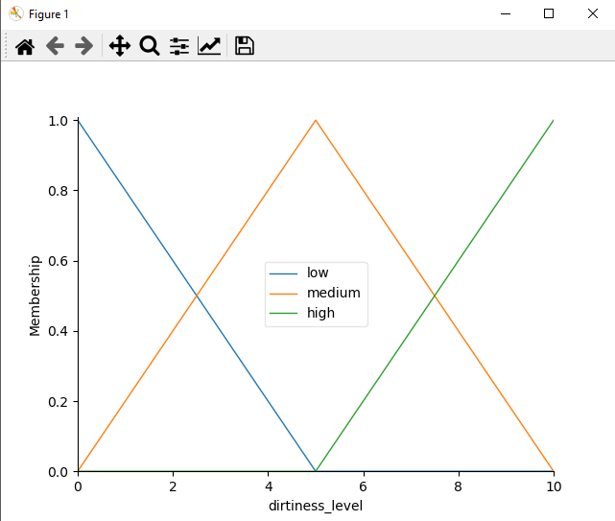

**Figure 2:** 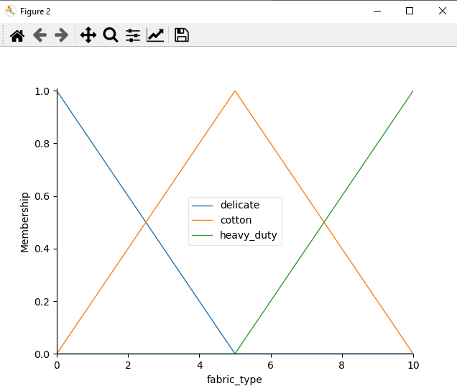

**Figure 3:**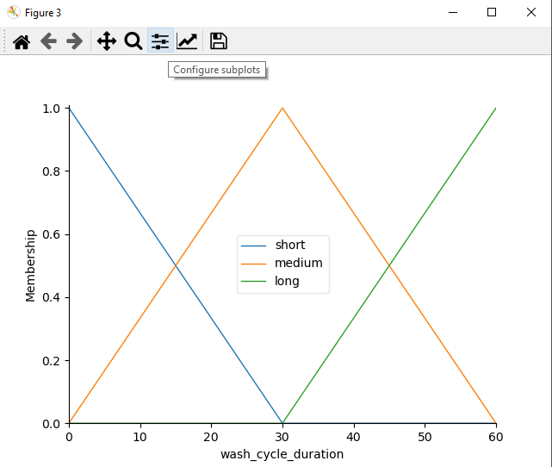

**Figure 4:**

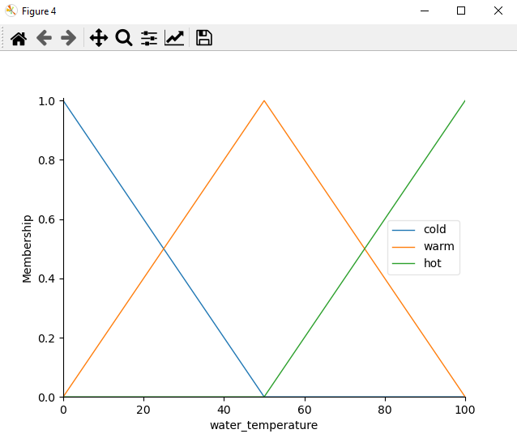

**Figure 5:**

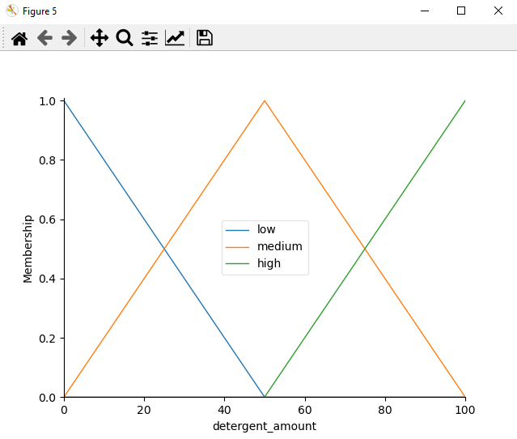

**2.Develope a simulation of a fuzzy traffic light controller for a busy intersection. Define fuzzy sets and membership functions for traffic flow (e.g. low, medium, high) and waiting time. Design fuzzy rules to determine the duration of green, yellow, and red lights based on traffic flow and waiting time. Simulate the traffic light controller and analyze its performance in terms of traffic congestion and waiting times.**

import numpy as np

import skfuzzy as fuzz

from skfuzzy import control as ctrl

import matplotlib.pyplot as plt

# Define input variables

traffic_flow = ctrl.Antecedent(np.arange(0, 101, 1), 'traffic_flow')

waiting_time = ctrl.Antecedent(np.arange(0, 61, 1), 'waiting_time')

# Define output variable

light_duration = ctrl.Consequent(np.arange(0, 101, 1), 'light_duration')

# Define fuzzy sets and membership functions

traffic_flow['low'] = fuzz.trimf(traffic_flow.universe, [0, 20, 40])

traffic_flow['medium'] = fuzz.trimf(traffic_flow.universe, [20, 40, 60])

traffic_flow['high'] = fuzz.trimf(traffic_flow.universe, [40, 60, 100])

waiting_time['low'] = fuzz.trimf(waiting_time.universe, [0, 10, 20])

waiting_time['medium'] = fuzz.trimf(waiting_time.universe, [10, 20, 30])

waiting_time['high'] = fuzz.trimf(waiting_time.universe, [20, 30, 60])

light_duration['green'] = fuzz.trimf(light_duration.universe, [0, 30, 60])

light_duration['yellow'] = fuzz.trimf(light_duration.universe, [30, 60, 90])

light_duration['red'] = fuzz.trimf(light_duration.universe, [60, 90, 100])

# Define fuzzy rules

rule1 = ctrl.Rule(traffic_flow['low'] | waiting_time['low'], light_duration['green'])

rule2 = ctrl.Rule(traffic_flow['medium'] & waiting_time['medium'], light_duration['yellow'])

rule3 = ctrl.Rule(traffic_flow['high'] | waiting_time['high'], light_duration['red'])

# Create control system

traffic_light_ctrl = ctrl.ControlSystem([rule1, rule2, rule3])

traffic_light_simulation = ctrl.ControlSystemSimulation(traffic_light_ctrl)

# Run simulation with specific inputs

traffic_light_simulation.input['traffic_flow'] = 48

traffic_light_simulation.input['waiting_time'] = 15

traffic_light_simulation.compute()

# Print simulation results

print("Light Duration:", traffic_light_simulation.output['light_duration'])

light_duration.view(sim=traffic_light_simulation)

plt.show()

**Output :-** **Light Duration: 50.92730085073477**

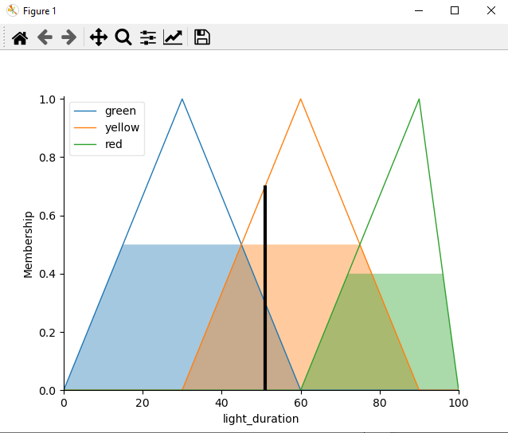

**6.Application of genetics algorithm to real world problems Generate Population**.

#GeneratePopulation

import numpy as np

# Define function to generate initial population

def generate_population(pop_size, chromosome_length, gene_range):

population = []

for _ in range(pop_size):

individual = np.random.randint(gene_range[0], gene_range[1] + 1, size=chromosome_length)

population.append(individual)

return population

# Example usage

pop_size = 4 # Population size

chromosome_length = 3 # Length of each chromosome

gene_range = (0, 3) # Range of possible values for genes

population = generate_population(pop_size, chromosome_length, gene_range)

for i, individual in enumerate(population):

print("Individual", i + 1, ":", individual)

**#Crossover**

import numpy as np

# Define crossover function

def crossover(parent1, parent2):

# Choose a random crossover point

crossover_point = np.random.randint(1, len(parent1))

# Perform crossover

child1 = parent1[:crossover_point] + parent2[crossover_point:]

child2 = parent2[:crossover_point] + parent1[crossover_point:]

return child1, child2

# Example usage

parent1 = [1, 2, 3, 4, 5]

parent2 = [5, 4, 3, 2, 1]

child1, child2 = crossover(parent1, parent2)

print("Parent 1:", parent1)

print("Parent 2:", parent2)

print("Child 1 after crossover:", child1)

print("Child 2 after crossover:", child2)

**#Mutation**

import numpy as np

# Define mutation function

def mutate(individual, mutation_rate):

mutated_individual = individual.copy()

for i in range(len(mutated_individual)):

if np.random.rand() < mutation_rate:

# Mutate the gene at index i

mutated_individual[i] = np.random.randint(0, 10) # Example: mutation within the range [0, 9]

return mutated_individual

# Example usage

individual = [1, 2, 3, 4, 5]

mutation_rate = 0.1 # Example: mutation rate of 10%

mutated_individual = mutate(individual, mutation_rate)

print("Original individual:", individual)

print("Mutated individual:", mutated_individual)

Output:-

Original individual: [1, 2, 3, 4, 5]

Mutated individual: [1, 9, 3, 8, 5]